Practical 2 :
Develop static HTML5 skeletons for at least 10 StudentHub pages such as Home, About, Register, Login, Dashboard, Events, Profile, Contact, Admin, FAQ, and Feedback. Use semantic tags and accessibility-friendly structure.

Login Page :
<!DOCTYPE html>
<html lang="en">
<head>
<meta charset="UTF-8">
<meta name="viewport" content="width=device-width, initial-scale=1.0">
<title>Student Hub Portal</title>
<table>
<tr>
<td>
<img src="images.jpg" alt="CHARUSAT" height="30%" width="30%">

</td>
<td>
<h1>Charotar University of Science and Technology</h1>
<h2 style="text-align: center; ">Student Hub Portal</h2>
</td>
</tr>
</table>

<hr>

</head>
<body>
<div style="background-image: url('image4.jpg'); background-size: cover; background-repeat: no-repeat; height: 100vh; width: 100vw;"></section>
<br><h3 style="margin-left: 53%;">Gateway to Student Hub Portal</h3><br><br>
<form action="dashboard.html" style="text-align: right; margin-left: 50%; margin-top: 20px; margin-bottom: 20px; padding: 20px; border: 2px solid black; width: 300px; background-color: rgba(255, 255, 255, 0.8);">

<fieldset>
<legend style="text-align: left;"> Username</legend>
<input type="text" id="fname" name="fname" required>
</fieldset>
</br></br>
<fieldset>
<legend style="text-align: left;"> Password</legend>
<input type="password" id="pass" name="pass" required >
</fieldset>

</br></br>
<!-- <div style="text-align: center;">
<input type="submit" value="NEXT">
</div> -->
<!-- HTML -->
<div style="text-align: center;">
<button type="submit">Login</button>
</div>
<p style="text-align: center;">Can't have account Click here to <a href="registration.html">registration</a></p>
</form>
</div>
</body>
</html>

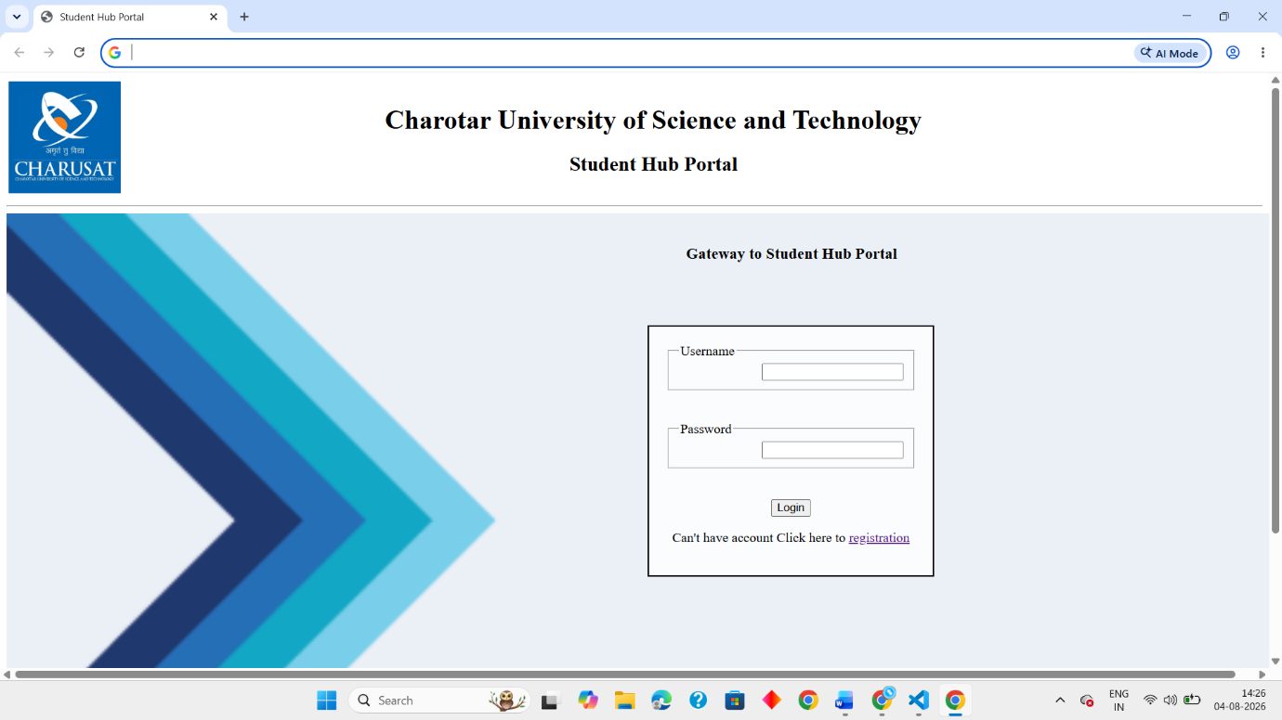

Registration Page :
<!DOCTYPE html>
<html lang="en">
<head>
<meta charset="UTF-8">
<meta name="viewport" content="width=device-width, initial-scale=1.0">
<title>Document</title>
<table>
<tr>
<td>
<img src="images.jpg" alt="CHARUSAT" height="30%" width="30%" >
</td>
<td>
<h1>Charotar University of Science and Technology</h1>
</td>
</tr>
</table>
<hr>
</head>
<body>
<h2 style="text-align: center;">Registration</h2><hr>

<section style="margin-left: 40%; margin-right: 10%;">
<label id="fname" >Name : </label>
<input type="text" id="fname" name="fname" ><br><br>

<label id="mail" >Mail : </label>
<input type="text" id="mail" name="mail" ><br><br>

<label id="role" >Role : </label>
<select id="role">
<option value="selectrole">-Select Role-</option>
<option value="Student">Student</option>
<option value="Faculty">Faculty</option>
</select><br><br>

<label id="date" >Date of Birth : </label>
<input type="date" id="date" name="date"><br><br>

<lable id="radio" >Gender : </lable>
<input type="radio" id="male" name="Gender" value="male">
<label for="male">Male</label>
<input type="radio" id="female" name="Gender" value="female">
<label for="female">Female</label><br><br>

<label for="address">Address : </label><br>
<textarea id="address" name="address" rows="5" cols="40" placeholder="Enter address"></textarea>
</section><br><br>
<div style="text-align: center;">
<button type="submit" onclick="window.location.href='dashboard.html'">Login</button>
</div>
</body>
</html>

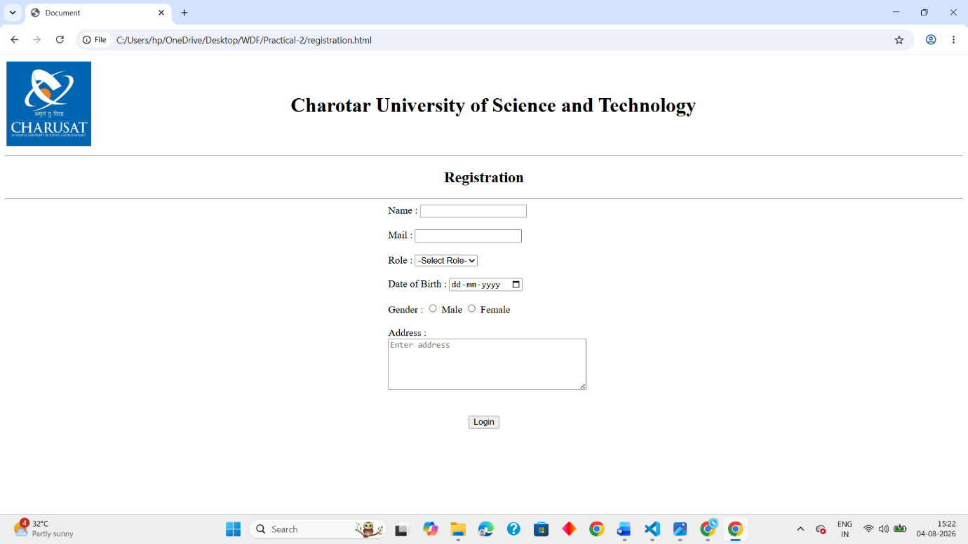

Dashboard :
<!DOCTYPE html>
<html lang="en">
<head>
<meta charset="UTF-8">
<meta name="viewport" content="width=device-width, initial-scale=1.0">
<title>Dashboard</title>
<table>
<tr>
<td>
<img src="images.jpg" alt="CHARUSAT" height="30%" width="30%" >
</td>
<td>
<h1>Charotar University of Science and Technology</h1>
</td>
</tr>
</table>
<hr>
</head>
<body>
<h2 style="text-align: center;">Dashboard</h2>
<hr><br><br>
<table border="1" style="margin-left: 25%; padding: 10px; width: 50%;">
<section style="margin-left: 10%; margin-right: 10%;"><br>
<tr>
<th>Student</th>
<th>Faculty</th>
</tr>
<tr>
<td>
<ul>
<li><a href="attandance.html">ATTANDANCE</a></li>
<li><a href="assignment.html">ASSIGNMENT</a></li>
<li><a href="timetable.html">TIME TABLE</a></li>
<li><a href="course.html">COURSES</a></li>
<li><a href="notes.html">NOTES</a></li>
<li><a href="notice.html">NOTICE</a></li>

</ul></td>
<td>
<ul>

<li><a href="attandance.html">STUDENT ATTANDENSE</a></li>
<li><a href="notes.html">NOTES</a></li>
<li><a href="assignment.html">ASSIGNMENT</a></li>
<li><a href="course.html">COURSES</a></li>
<li><a href="contactUs.html">CONTACT US</a></li>
</ul>
</td></tr>
</section>
</table>

</body>
</html>

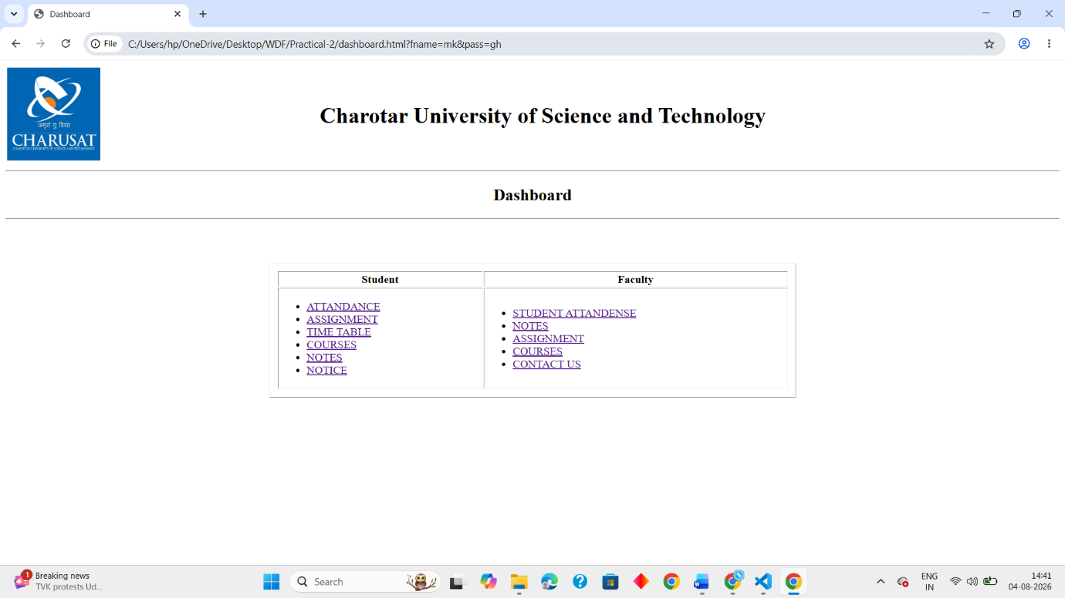

Attendance :
<!DOCTYPE html>
<html lang="en">
<head>
<meta charset="UTF-8">
<meta name="viewport" content="width=device-width, initial-scale=1.0">
<meta name="description" content="StudentHub Attendance — View your overall and course-wise attendance records.">
<title>Attendance</title>
<table>
<tr>
<td>
<img src="images.jpg" alt="CHARUSAT" height="30%" width="30%" >
</td>
<td>
<h1>Charotar University of Science and Technology</h1>
</td>
</tr>
</table>
<hr>
</head>
<body>
<h2 style="text-align: center;">Attendance Record</h2><hr>
<section style="margin-left: 20%; margin-right: 10%;">
<table border="1" cellpadding="10">
<tr>
<th scope="col">Course</th>
<th scope="col">Total</th>
<th scope="col">Present</th>
<th scope="col">Absent</th>
<th scope="col">Percentage</th>
</tr>

<tr>
<td>CSUC201 FUNDAMENTALS OF DATA STRUCTURE AND ALGORITHMS</td>
<td>24</td>
<td>22</td>
<td>2</td>
<td>92%</td>
</tr>
<tr>
<td>ITUE203 Web Development</td>
<td>18</td>
<td>17</td>
<td>1</td>
<td>94%</td>
</tr>
<tr>
<td>CEUE203 OBJECT ORIENTED PROGRAMMING</td>
<td>22</td>
<td>20</td>
<td>2</td>
<td>91%</td>
</tr>
<tr>
<td>MSUD203 DISCRETE MATHEMATICS</td>
<td>20</td>
<td>18</td>
<td>2</td>
<td>90%</td>
</tr>
<tr>
<td>ITUC201 FUNDAMENTALS OF COMPUTER NETWORKS</td>
<td>18</td>
<td>17</td>
<td>1</td>
<td>94%</td>
</tr>
<tr>
<td>HSUV201 CREATIVITY,PROBLEM SOLVING AND INNOVATION</td>
<td>18</td>
<td>16</td>
<td>2</td>
<td>89%</td>
</tr>

</table>
</section><br><br>
<div style="text-align: center;">
<button type="button" onclick="location.href='dashboard.html'">Back to Dashboard</button>
</div>
</body>
</html>

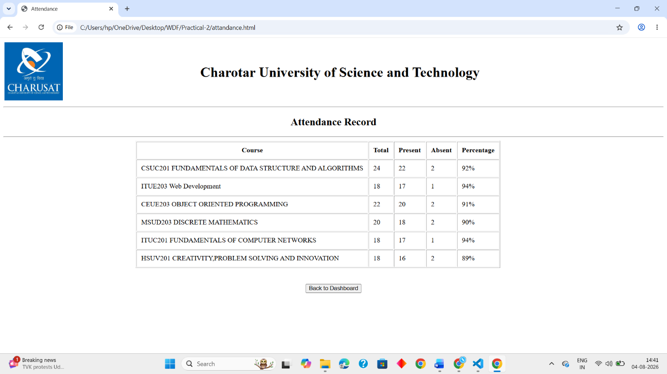

Assignment :

<!DOCTYPE html>
<html lang="en">
<head>
<meta charset="UTF-8">
<meta name="viewport" content="width=device-width, initial-scale=1.0">
<title>Assignment</title>
<table>
<tr>
<td>
<img src="images.jpg" alt="CHARUSAT" height="30%" width="30%" >
</td>
<td>
<h1>Charotar University of Science and Technology</h1>
</td>
</tr>
</table>
<hr>
</head>
<body>
<h2 style="text-align: center;">Assignments</h2><hr>
<ol>
<li>DSA</li>
<ul>
<a href="assignment1.html"><li>Assignment 1</li></a>
<a href="assignment2.html"><li>Assignment 2</li></a>
<a href="assignment3.html"><li>Assignment 3</li></a>
</ul>

<li>WDF</li>
<ul>
<a href="assignment1.html"><li>Assignment 1</li></a>
<a href="assignment2.html"><li>Assignment 2</li></a>
<a href="assignment3.html"><li>Assignment 3</li></a>
</ul>

<li>OOP</li>
<ul>
<a href="assignment1.html"><li>Assignment 1</li></a>
<a href="assignment2.html"><li>Assignment 2</li></a>
<a href="assignment3.html"><li>Assignment 3</li></a>
</ul>
</ol><br><br>
<div style="text-align: center;">
<button type="button" onclick="location.href='dashboard.html'">Back to Dashboard</button>
</div>
</body>
</html>

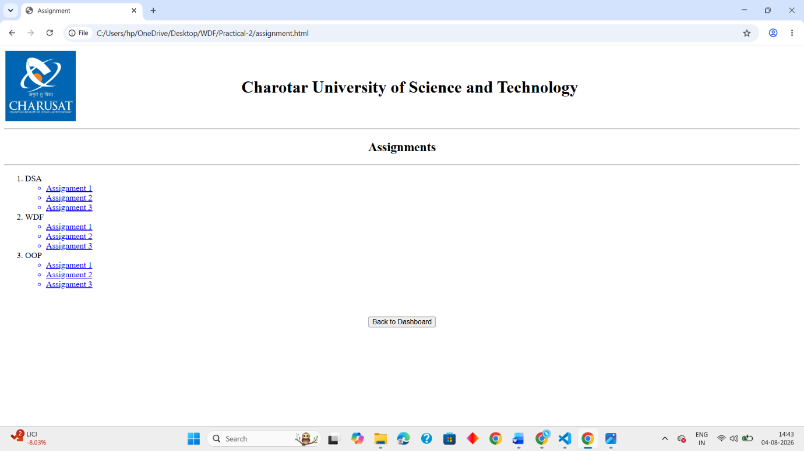

Time table :
<!DOCTYPE html>
<html lang="en">
<head>
<meta name="viewport" content="width=device-width" initial-scale="1.0">
<meta charset="UTF-8">
<title>Time-Table</title>
<style>
table {
width: 100%;

}

table, th, td {
border: 2px solid black;
}

th, td {
padding: 5px;
text-align: center;
}

th:hover {background-color: #D6EEEE;}
td:hover {background-color: #D6EEEE;}

</style>
</head>
<body>
<div class="time-table">
<h2 style="text-align: center;">Weekly Time-Table</h2><hr>

<table style="width: 100%;">
<tr>
<th colspan="6">CHARUSAT UNIVERSITY DEPSTAR-3IT</th>
</tr>

<tr>
<th>Time-Sloats</th>
<th>Monday</th>
<th>Tuesday</th>
<th>Wednesday</th>
<th>Thursday</th>
<th>Friday</th>
</tr>

<tr>
<td>9:10-10:10</td>
<td>ITUE203<br>WDF<br>222<br>JV</td>
<td>ITUC201<br>FCN<br>123<br>RHP</td>
<td>MSUD203<br>DM<br>124<br>RVS</td>
<td>A:CSUC201<br>FDSA<br>123<br>CUR</td>
<td>ITUE203<br>WDF<br>JV</td>
</tr>

<tr>
<td>10:10-11:10</td>
<td>ITUC201<br>FCN<br>222<br>RHP</td>
<td>CEUE203<br>OOP<br>123<br>DAG</td>
<td>CSUC201<br>FDSA<br>124<br>PHP</td>
<td>CEUE203<br>OOP<br>123<br>DAG</td>
<td>MSUD203<br>DM<br>124<br>RVS</td>
</tr>

<tr >
<td>11:10-12:10</td>
<td colspan="5 " style="height: 12px;">Lunch-Break</td>
</tr>

<tr>
<td>12:10-1:10</td>
<td rowspan="2">A:ITUC201<br>FCN(P)<br>218<br>MH</td>
<td>MSUD203<br>DM<br>123<br>RVS</td>
<td>ITUC201<br>FCN<br>125<br>RHP</td>
<td rowspan="2">HSUV201<br>CPI<br>123<br>VHP</td>
<td rowspan="2">CEUE203<br>OOP(P)<br>204<br>MPD</td>

</tr>

<tr>
<td>1:10-2:10</td>
<td>Counselling<br>session<br>123<br>SYS</td>
<td>Counselling<br> session<br>125<br>PC</td>

</tr>

<tr >
<td>2:10-2:20</td>
<td colspan="5 " style="height: 12px;">Short-Break</td>
</tr>

<tr>
<td>2:20:3:20</td>
<td rowspan="2">A:CSUC201<br>FDSA(P)<br>208<br>ARP</td>
<td rowspan="2">A:ITUE203<br>WDF(P)<br>206<br>JP</td>
<td rowspan="2">A:ITUE203<br>WDF(P)<br>208<br>SHP</td>
<td>ITUE203<br>WDF<br>329<br>VKM</td>
<td>CSUC201<br>FDSA<br>123<br>CUR</td>
</tr>

<tr>
<td>3:20-4:20</td>
<td>MSUD203<br>DM<br>123<br>RVS</td>
<td>ITUC201<br>FCN<br>125<br>RHP</td>

</tr>

</table>
</div><br><br>
<div style="text-align: center;">
<button type="button" onclick="location.href='dashboard.html'">Back to Dashboard</button>
</div>
</body>
</html>

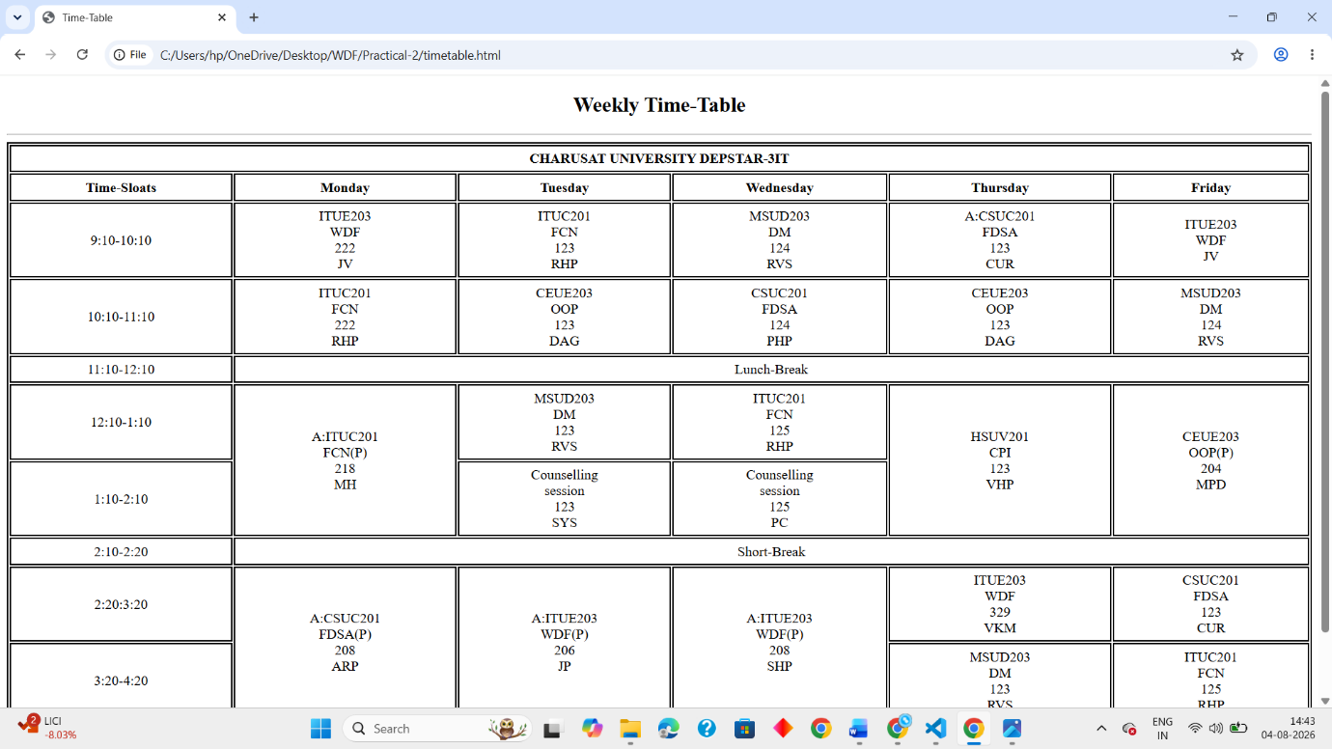

Courses :
<!DOCTYPE html>
<html lang="en">
<head>
<meta charset="UTF-8">
<meta name="viewport" content="width=device-width, initial-scale=1.0">
<meta name="description" content="StudentHub Courses — Browse the courses available this semester.">
<title>Registered Courses</title>
<table>
<tr>
<td>
<img src="images.jpg" alt="CHARUSAT" height="30%" width="30%" >
</td>
<td>
<h1>Charotar University of Science and Technology</h1>
</td>
</tr>
</table>
<hr>
</head>
<body>

<h2 style="text-align: center;">Registered Courses</h2><hr>

<section style="margin-left: 20%; margin-right: 10%;">
<table border="1">
<tr>
<th>Code</th>
<th>Course Name</th>
<th>Faculty</th>
<th>Credits</th>
<th>Semester</th>
</tr>

<tr>
<td>ITUC201</td>
<td>FUNDAMENTALS OF COMPUTER NETWORK</td>
<td>Ms.Radhika Patel</td>
<td>4+1</td>
<td>Sem 3</td>
</tr>
<tr>
<td>CSUC201</td>
<td>FUNDAMENTALS OF DATA STRUCTURE AND ALGORITHMS</td>
<td>Mr.Akash Patel</td>
<td>3+1</td>
<td>Sem 3</td>
</tr>
<tr>
<td>ITUE203</td>
<td>WEB DEVELOPMENT FRAMEWORKS</td>
<td>Mr.Vaibhav Mataliya</td>
<td>3+2</td>
<td>Sem 3</td>
</tr>
<tr>
<td>CEUE203</td>
<td>OBJECT ORIENTED PROGRAMMING</td>
<td>Dr.Deven Gol</td>
<td>2+1</td>
<td>Sem 3</td>
</tr>
<tr>
<td>MSUD203</td>
<td>DISCRETE MATHEMATICS</td>
<td>Dr.Rajesh Savaliya</td>
<td>3</td>
<td>Sem 3</td>
</tr>

</table>
</section><br><br>
<div style="text-align: center;">
<button type="button" onclick="location.href='dashboard.html'">Back to Dashboard</button>
</div>
</body>
</html>

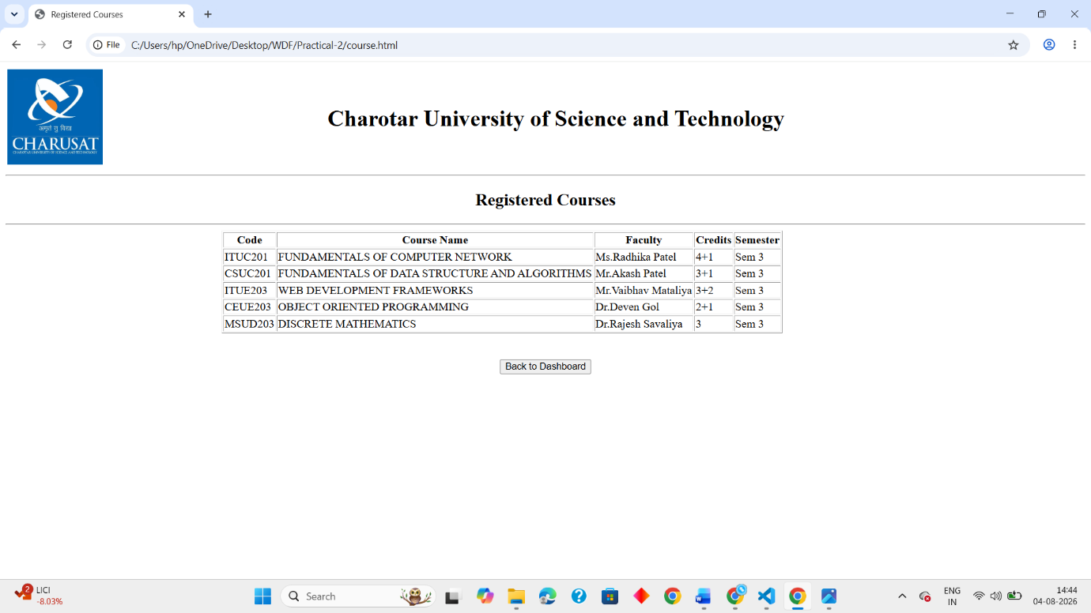

Notes :
<!DOCTYPE html>
<html lang="en">
<head>
<meta charset="UTF-8">
<meta name="viewport" content="width=device-width, initial-scale=1.0">
<title>Document</title>
<table>
<tr>
<td>
<img src="images.jpg" alt="CHARUSAT" height="30%" width="30%" >
</td>
<td>
<h1>Charotar University of Science and Technology</h1>
</td>
</tr>
</table>
<hr>
</head>
<body>
<h2 style="text-align: center;">Notes</h2><hr>
<ul>
<li>DSA Notes</li>
<li>WDF Notes</li>
<li>OOP Notes</li>
<li>JAVA Notes</li>
</ul><br><br>
<div style="text-align: center;">
<button type="button" onclick="location.href='dashboard.html'">Back to Dashboard</button>
</div>
</body>
</html>

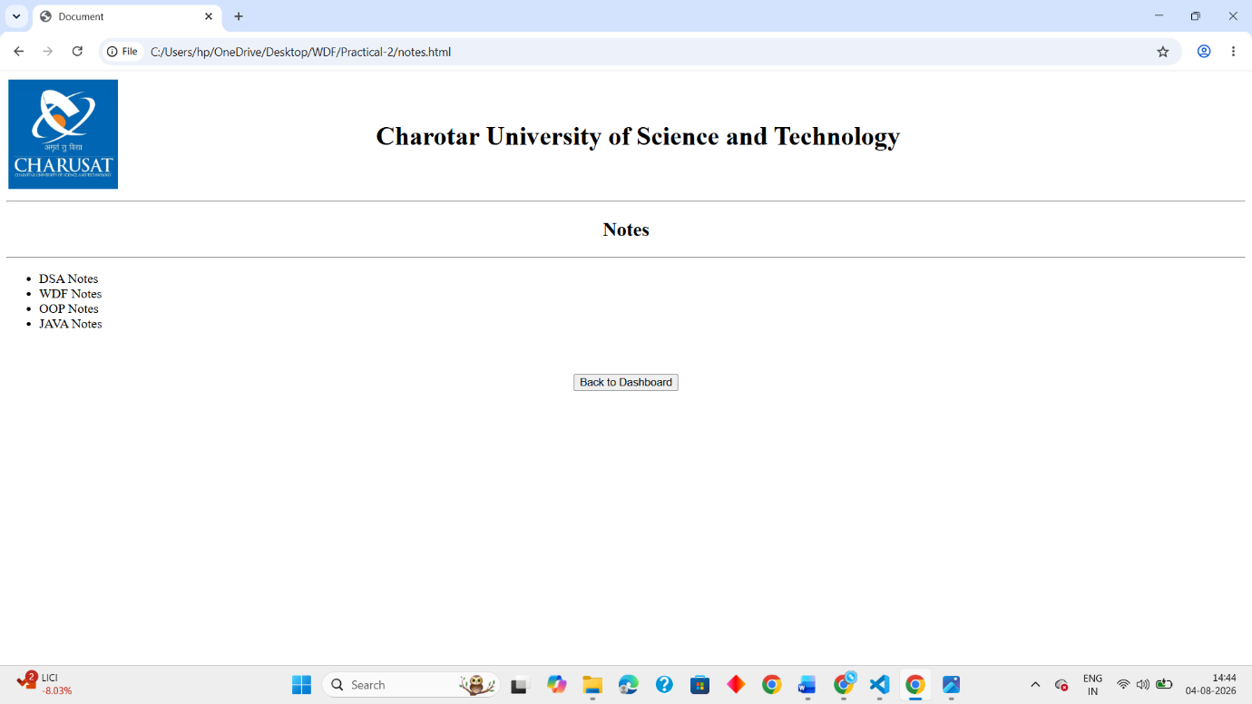

Notice :
<!DOCTYPE html>
<html lang="en">
<head>
<meta charset="UTF-8">
<meta name="viewport" content="width=device-width, initial-scale=1.0">
<title>Notice</title>
<table>
<tr>
<td>
<img src="images.jpg" alt="CHARUSAT" height="30%" width="30%" >
</td>
<td>
<h1>Charotar University of Science and Technology</h1>
</td>
</tr>
</table>
<hr>
</head>
<body>
<h2 style="text-align: center;">Notice</h2><br><br>
<ul>
<li>2<sup>nd</sup> year commmenced from july 06,2026</li>
<li>CIE 1 will start from july 27,2026</li>
</ul><br><br>
<div style="text-align: center;">
<button type="button" onclick="location.href='dashboard.html'">Back to Dashboard</button>
</div>
</body>
</html>
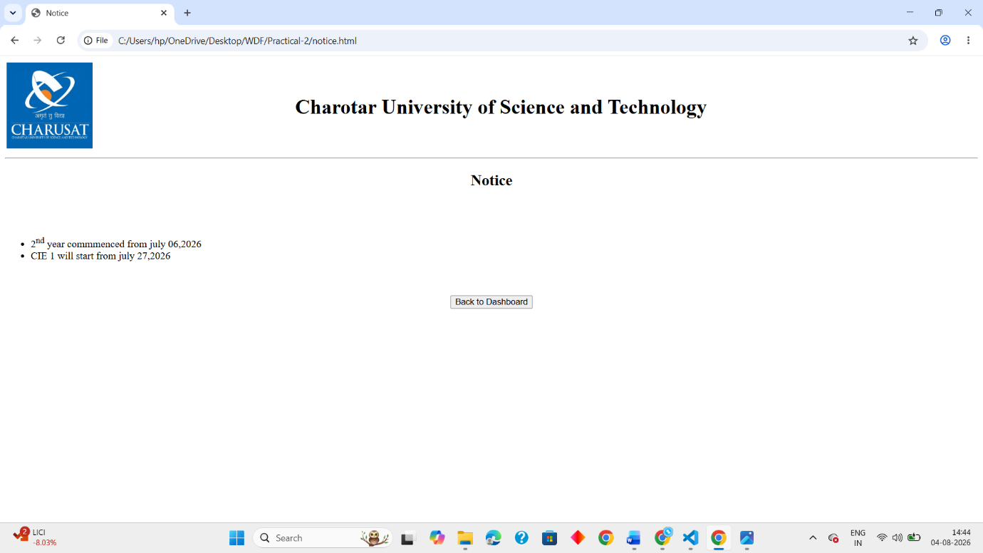

Contact Us :
<!DOCTYPE html>
<html lang="en">
<head>
<meta charset="UTF-8">
<meta name="viewport" content="width=device-width" ,initial-scale="1.0">
<title>StudentHub - Home</title>
<style>

body{
margin: 0;
}

.feedback{
display: flex;
justify-content: center;
align-items: center;
height: 100vh;
}

.contact-section{
width: 400px;
padding: 20px;
border: 2px solid black;
border-radius: 10px;
text-align: center;
}

</style>
</head>
<body>

<div class="feedback">
<section class="contact-section" id="contact">
<h2>Contact Us</h2>
<p>If you have any questions, feedback, or just want to say hi, feel free to reach out!</p>
<form class="contact-form">
<label for="name">Name:</label>
<input type="text" id="name" name="name" required><br><br>

<label for="email">Email:</label>
<input type="email" id="email" name="email" required><br><br>

<p>Massage :</p>
<textarea id="message" name="message" rows="5" required></textarea><br>
<button type="submit">Send Message</button>
</form>
</section>
</div>
<div style="text-align: center;">
<button type="button" onclick="location.href='dashboard.html'">Back to Dashboard</button>
</div>
</body>
</html>

